ML_Dataiku_Pipeline_project

short line



|  |  |  |
| --- | --- | --- |
| **Version** | **Author** | **Date** |
| 1.0 | abhishek.barandooru | 2023-08-29 14:32:21 |

Table of contents

I. Project general description 4

II. Graphical Representation of the Flow 5

III. Datasets 6

1. {{$dataset.name}} 6

a) Status of the dataset {{$dataset.name}} 6

b) Related Recipes 7

c) Schema 7

IV. Managed folders 9

1. {{$folder.name}} 9

a) Status 9

b) Derived datasets 10

c) Related Recipes 10

V. Recipes 11

1. {{ $recipe.name }} 11

a) Status 11

b) Inputs / Outputs 11

c) Prepare Steps 12

d) Join 12

e) Data Relationships 13

f) Feature Transformations 14

g) Code 14

h) Windows 15

i) Sorted Columns 15

j) Top rows and sorting direction 15

k) Parameters 16

VI. Saved Models 17

1. {{ $model.name }} 17

a) Status 17

b) Related Recipes 17

VII. Model Evaluation Stores 19

1. {{ $mes.name }} 19

a) Related Recipes 19

VIII. Labeling Tasks 21

1. {{ $labeling_task.name }} 21

a) Status 21

b) Inputs / Outputs 21

IX. Deployment and Monitoring 23

A. Implementation Details 23

B. Version Control 23

# Project general description

Project references for the created flow:

* Project name: **ML_Dataiku_Pipeline_project**
* Project key: **ML_DATAIKU_PIPELINE_PROJECT**
* Project short description:

The project *ML_Dataiku_Pipeline_project* was created by abhishek.barandooru on Aug 29th 2023

* Status: **Sandbox**
* Current git branch: **master**
* Created by abhishek.barandooru on the 2023-08-29 13:09:48
* Last Modification by api:14VF4LADSLYJP81X (deleted) on the 2023-08-29 13:26:34

# Graphical Representation of the Flow

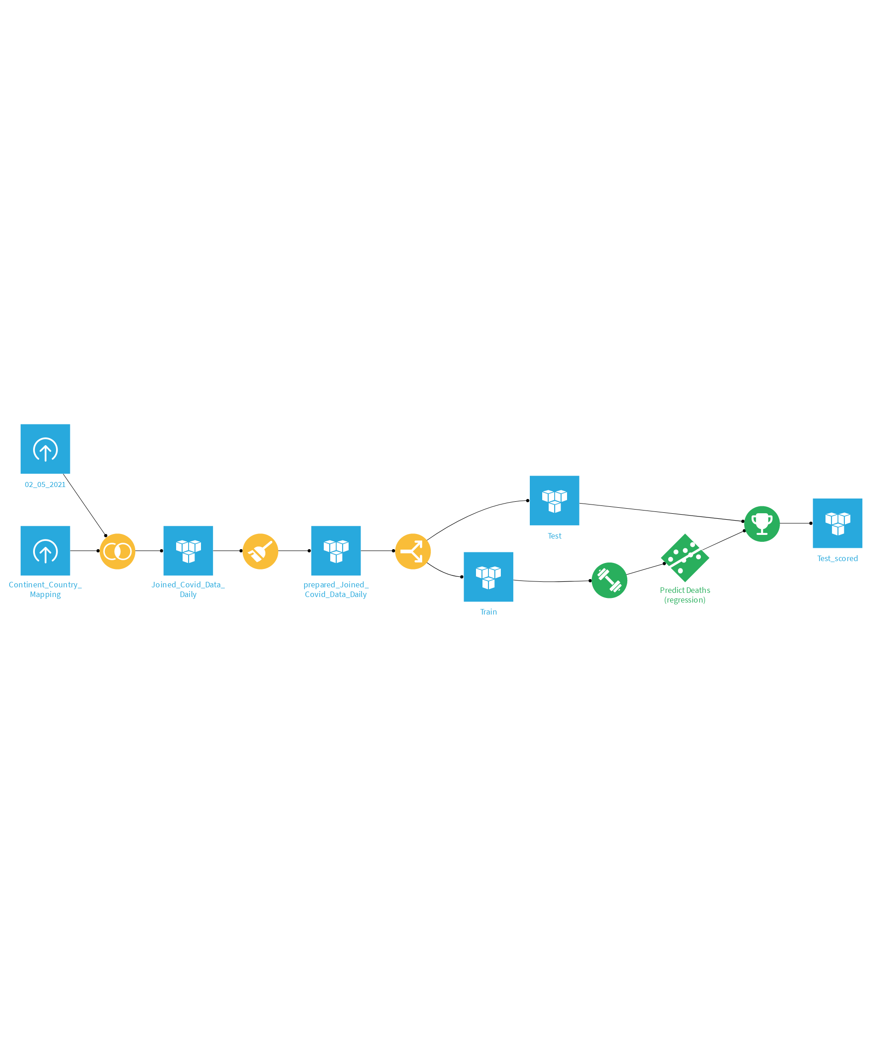

# Datasets

List all the datasets in the flow.

### 02_05_2021

Summarized information about your dataset 02_05_2021:

#### Status of the dataset 02_05_2021

Characteristics of the dataset 02_05_2021:

* Type: **Uploaded Files**
* Connection: **dataiku-managed-storage**
* Total Size: **Not computed**
* Record Count: **3,984**
* Created by abhishek.barandooru on the 2023-08-29 13:19:22
* Last Modification by abhishek.barandooru on the 2023-08-29 13:19:22

#### Related Recipes

The dataset 02_05_2021 relates to the following recipes.

Successor Recipes

List of recipes with 02_05_2021 as an input:

* compute_Joined_Covid_Data_Daily (Join)

#### Schema

Schema details of the dataset.

|  |  |  |
| --- | --- | --- |
| ****Column Name**** | Column Type | Description |

|  |  |  |
| --- | --- | --- |
| ****FIPS**** | string |  |

|  |  |  |
| --- | --- | --- |
| ****Admin2**** | string |  |

|  |  |  |
| --- | --- | --- |
| ****Province_State**** | string |  |

|  |  |  |
| --- | --- | --- |
| ****Country_Region**** | string |  |

|  |  |  |
| --- | --- | --- |
| ****Last_Update**** | string |  |

|  |  |  |
| --- | --- | --- |
| ****Lat**** | string |  |

|  |  |  |
| --- | --- | --- |
| ****Long_**** | string |  |

|  |  |  |
| --- | --- | --- |
| ****Confirmed**** | string |  |

|  |  |  |
| --- | --- | --- |
| ****Deaths**** | string |  |

|  |  |  |
| --- | --- | --- |
| ****Recovered**** | string |  |

|  |  |  |
| --- | --- | --- |
| ****Active**** | string |  |

|  |  |  |
| --- | --- | --- |
| ****Combined_Key**** | string |  |

|  |  |  |
| --- | --- | --- |
| ****Incident_Rate**** | string |  |

|  |  |  |
| --- | --- | --- |
| ****Case_Fatality_Ratio**** | string |  |

### Continent_Country_Mapping

Summarized information about your dataset Continent_Country_Mapping:

#### Status of the dataset Continent_Country_Mapping

Characteristics of the dataset Continent_Country_Mapping:

* Type: **Uploaded Files**
* Connection: **dataiku-managed-storage**
* Total Size: **Not computed**
* Record Count: **182**
* Created by abhishek.barandooru on the 2023-08-29 13:16:05
* Last Modification by abhishek.barandooru on the 2023-08-29 13:16:08

#### Related Recipes

The dataset Continent_Country_Mapping relates to the following recipes.

Successor Recipes

List of recipes with Continent_Country_Mapping as an input:

* compute_Joined_Covid_Data_Daily (Join)

#### Schema

Schema details of the dataset.

|  |  |  |
| --- | --- | --- |
| ****Column Name**** | Column Type | Description |

|  |  |  |
| --- | --- | --- |
| ****Country_Name**** | string |  |

|  |  |  |
| --- | --- | --- |
| ****Continent_Name**** | string |  |

|  |  |  |
| --- | --- | --- |
| ****Continent_Code**** | string |  |

### Joined_Covid_Data_Daily

Summarized information about your dataset Joined_Covid_Data_Daily:

#### Status of the dataset Joined_Covid_Data_Daily

Characteristics of the dataset Joined_Covid_Data_Daily:

* Type: **Amazon S3**
* Connection: **dataiku-managed-storage**
* Total Size: **271.2 KB**
* Record Count: **3,984**
* Created by abhishek.barandooru on the 2023-08-29 13:26:29
* Last Modification by abhishek.barandooru on the 2023-08-29 13:26:29

#### Related Recipes

The dataset Joined_Covid_Data_Daily relates to the following recipes.

Parent Recipe

List of recipes with Joined_Covid_Data_Daily as an output:

* compute_Joined_Covid_Data_Daily (Join)

Successor Recipes

List of recipes with Joined_Covid_Data_Daily as an input:

* compute_prepared_Joined_Covid_Data_Daily (Prepare)

#### Schema

Schema details of the dataset.

|  |  |  |
| --- | --- | --- |
| ****Column Name**** | Column Type | Description |

|  |  |  |
| --- | --- | --- |
| ****FIPS**** | string |  |

|  |  |  |
| --- | --- | --- |
| ****Admin2**** | string |  |

|  |  |  |
| --- | --- | --- |
| ****Province_State**** | string |  |

|  |  |  |
| --- | --- | --- |
| ****Country_Region**** | string |  |

|  |  |  |
| --- | --- | --- |
| ****Last_Update**** | string |  |

|  |  |  |
| --- | --- | --- |
| ****Lat**** | string |  |

|  |  |  |
| --- | --- | --- |
| ****Long_**** | string |  |

|  |  |  |
| --- | --- | --- |
| ****Confirmed**** | string |  |

|  |  |  |
| --- | --- | --- |
| ****Deaths**** | string |  |

|  |  |  |
| --- | --- | --- |
| ****Recovered**** | string |  |

|  |  |  |
| --- | --- | --- |
| ****Active**** | string |  |

|  |  |  |
| --- | --- | --- |
| ****Combined_Key**** | string |  |

|  |  |  |
| --- | --- | --- |
| ****Incident_Rate**** | string |  |

|  |  |  |
| --- | --- | --- |
| ****Case_Fatality_Ratio**** | string |  |

|  |  |  |
| --- | --- | --- |
| ****Country_Name**** | string |  |

|  |  |  |
| --- | --- | --- |
| ****Continent_Name**** | string |  |

|  |  |  |
| --- | --- | --- |
| ****Continent_Code**** | string |  |

### prepared_Joined_Covid_Data_Daily

Summarized information about your dataset prepared_Joined_Covid_Data_Daily:

#### Status of the dataset prepared_Joined_Covid_Data_Daily

Characteristics of the dataset prepared_Joined_Covid_Data_Daily:

* Type: **Amazon S3**
* Connection: **dataiku-managed-storage**
* Total Size: **214.3 KB**
* Record Count: **Not computed**
* Created by abhishek.barandooru on the 2023-08-29 13:33:23
* Last Modification by abhishek.barandooru on the 2023-08-29 13:33:23

#### Related Recipes

The dataset prepared_Joined_Covid_Data_Daily relates to the following recipes.

Parent Recipe

List of recipes with prepared_Joined_Covid_Data_Daily as an output:

* compute_prepared_Joined_Covid_Data_Daily (Prepare)

Successor Recipes

List of recipes with prepared_Joined_Covid_Data_Daily as an input:

* split_prepared_Joined_Covid_Data_Daily (Split)

#### Schema

Schema details of the dataset.

|  |  |  |
| --- | --- | --- |
| ****Column Name**** | Column Type | Description |

|  |  |  |
| --- | --- | --- |
| ****FIPS**** | string |  |

|  |  |  |
| --- | --- | --- |
| ****Admin2**** | string |  |

|  |  |  |
| --- | --- | --- |
| ****Province_State**** | string |  |

|  |  |  |
| --- | --- | --- |
| ****Country_Region**** | string |  |

|  |  |  |
| --- | --- | --- |
| ****Last_Update**** | string |  |

|  |  |  |
| --- | --- | --- |
| ****Lat**** | string |  |

|  |  |  |
| --- | --- | --- |
| ****Long_**** | string |  |

|  |  |  |
| --- | --- | --- |
| ****Confirmed**** | string |  |

|  |  |  |
| --- | --- | --- |
| ****Deaths**** | string |  |

|  |  |  |
| --- | --- | --- |
| ****Recovered**** | string |  |

|  |  |  |
| --- | --- | --- |
| ****Active**** | string |  |

|  |  |  |
| --- | --- | --- |
| ****Combined_Key**** | string |  |

|  |  |  |
| --- | --- | --- |
| ****Incident_Rate**** | string |  |

|  |  |  |
| --- | --- | --- |
| ****Case_Fatality_Ratio**** | string |  |

|  |  |  |
| --- | --- | --- |
| ****Country_Name**** | string |  |

|  |  |  |
| --- | --- | --- |
| ****Continent_Name**** | string |  |

|  |  |  |
| --- | --- | --- |
| ****Continent_Code**** | string |  |

### Train

Summarized information about your dataset Train:

#### Status of the dataset Train

Characteristics of the dataset Train:

* Type: **Amazon S3**
* Connection: **dataiku-managed-storage**
* Total Size: **156.5 KB**
* Record Count: **2,331**
* Created by abhishek.barandooru on the 2023-08-29 13:38:10
* Last Modification by abhishek.barandooru on the 2023-08-29 13:40:04

#### Related Recipes

The dataset Train relates to the following recipes.

Parent Recipe

List of recipes with Train as an output:

* split_prepared_Joined_Covid_Data_Daily (Split)

Successor Recipes

List of recipes with Train as an input:

* train_Predict_Deaths__regression_ (Prediction Training)

#### Schema

Schema details of the dataset.

|  |  |  |
| --- | --- | --- |
| ****Column Name**** | Column Type | Description |

|  |  |  |
| --- | --- | --- |
| ****FIPS**** | string |  |

|  |  |  |
| --- | --- | --- |
| ****Admin2**** | string |  |

|  |  |  |
| --- | --- | --- |
| ****Province_State**** | string |  |

|  |  |  |
| --- | --- | --- |
| ****Country_Region**** | string |  |

|  |  |  |
| --- | --- | --- |
| ****Last_Update**** | string |  |

|  |  |  |
| --- | --- | --- |
| ****Lat**** | string |  |

|  |  |  |
| --- | --- | --- |
| ****Long_**** | string |  |

|  |  |  |
| --- | --- | --- |
| ****Confirmed**** | string |  |

|  |  |  |
| --- | --- | --- |
| ****Deaths**** | string |  |

|  |  |  |
| --- | --- | --- |
| ****Recovered**** | string |  |

|  |  |  |
| --- | --- | --- |
| ****Active**** | string |  |

|  |  |  |
| --- | --- | --- |
| ****Combined_Key**** | string |  |

|  |  |  |
| --- | --- | --- |
| ****Incident_Rate**** | string |  |

|  |  |  |
| --- | --- | --- |
| ****Case_Fatality_Ratio**** | string |  |

|  |  |  |
| --- | --- | --- |
| ****Country_Name**** | string |  |

|  |  |  |
| --- | --- | --- |
| ****Continent_Name**** | string |  |

|  |  |  |
| --- | --- | --- |
| ****Continent_Code**** | string |  |

### Test

Summarized information about your dataset Test:

#### Status of the dataset Test

Characteristics of the dataset Test:

* Type: **Amazon S3**
* Connection: **dataiku-managed-storage**
* Total Size: **69.6 KB**
* Record Count: **Not computed**
* Created by abhishek.barandooru on the 2023-08-29 13:38:27
* Last Modification by abhishek.barandooru on the 2023-08-29 13:40:04

#### Related Recipes

The dataset Test relates to the following recipes.

Parent Recipe

List of recipes with Test as an output:

* split_prepared_Joined_Covid_Data_Daily (Split)

Successor Recipes

List of recipes with Test as an input:

* score_Test (Prediction Scoring)

#### Schema

Schema details of the dataset.

|  |  |  |
| --- | --- | --- |
| ****Column Name**** | Column Type | Description |

|  |  |  |
| --- | --- | --- |
| ****FIPS**** | string |  |

|  |  |  |
| --- | --- | --- |
| ****Admin2**** | string |  |

|  |  |  |
| --- | --- | --- |
| ****Province_State**** | string |  |

|  |  |  |
| --- | --- | --- |
| ****Country_Region**** | string |  |

|  |  |  |
| --- | --- | --- |
| ****Last_Update**** | string |  |

|  |  |  |
| --- | --- | --- |
| ****Lat**** | string |  |

|  |  |  |
| --- | --- | --- |
| ****Long_**** | string |  |

|  |  |  |
| --- | --- | --- |
| ****Confirmed**** | string |  |

|  |  |  |
| --- | --- | --- |
| ****Deaths**** | string |  |

|  |  |  |
| --- | --- | --- |
| ****Recovered**** | string |  |

|  |  |  |
| --- | --- | --- |
| ****Active**** | string |  |

|  |  |  |
| --- | --- | --- |
| ****Combined_Key**** | string |  |

|  |  |  |
| --- | --- | --- |
| ****Incident_Rate**** | string |  |

|  |  |  |
| --- | --- | --- |
| ****Case_Fatality_Ratio**** | string |  |

|  |  |  |
| --- | --- | --- |
| ****Country_Name**** | string |  |

|  |  |  |
| --- | --- | --- |
| ****Continent_Name**** | string |  |

|  |  |  |
| --- | --- | --- |
| ****Continent_Code**** | string |  |

### Test_scored

Summarized information about your dataset Test_scored:

#### Status of the dataset Test_scored

Characteristics of the dataset Test_scored:

* Type: **Amazon S3**
* Connection: **dataiku-managed-storage**
* Total Size: **59.6 KB**
* Record Count: **946**
* Created by abhishek.barandooru on the 2023-08-29 14:02:00
* Last Modification by abhishek.barandooru on the 2023-08-29 14:02:00

#### Related Recipes

The dataset Test_scored relates to the following recipes.

Parent Recipe

List of recipes with Test_scored as an output:

* score_Test (Prediction Scoring)

#### Schema

Schema details of the dataset.

|  |  |  |
| --- | --- | --- |
| ****Column Name**** | Column Type | Description |

|  |  |  |
| --- | --- | --- |
| ****FIPS**** | bigint |  |

|  |  |  |
| --- | --- | --- |
| ****Admin2**** | string |  |

|  |  |  |
| --- | --- | --- |
| ****Province_State**** | string |  |

|  |  |  |
| --- | --- | --- |
| ****Country_Region**** | string |  |

|  |  |  |
| --- | --- | --- |
| ****Last_Update**** | string |  |

|  |  |  |
| --- | --- | --- |
| ****Lat**** | double |  |

|  |  |  |
| --- | --- | --- |
| ****Long_**** | double |  |

|  |  |  |
| --- | --- | --- |
| ****Confirmed**** | bigint |  |

|  |  |  |
| --- | --- | --- |
| ****Deaths**** | bigint |  |

|  |  |  |
| --- | --- | --- |
| ****Recovered**** | bigint |  |

|  |  |  |
| --- | --- | --- |
| ****Active**** | bigint |  |

|  |  |  |
| --- | --- | --- |
| ****Combined_Key**** | string |  |

|  |  |  |
| --- | --- | --- |
| ****Incident_Rate**** | double |  |

|  |  |  |
| --- | --- | --- |
| ****Case_Fatality_Ratio**** | double |  |

|  |  |  |
| --- | --- | --- |
| ****Country_Name**** | string |  |

|  |  |  |
| --- | --- | --- |
| ****Continent_Name**** | string |  |

|  |  |  |
| --- | --- | --- |
| ****Continent_Code**** | string |  |

|  |  |  |
| --- | --- | --- |
| ****prediction**** | float |  |

# Recipes

List all the recipes in the flow.

### compute_Joined_Covid_Data_Daily

Summarized information about the recipe compute_Joined_Covid_Data_Daily.

#### Status

Characteristics of the recipe compute_Joined_Covid_Data_Daily:

* Type: **Join**
* Created by abhishek.barandooru on the 2023-08-29 13:26:29
* Last Modification by abhishek.barandooru on the 2023-08-29 13:30:03

#### Inputs / Outputs

List of the inputs of the recipe:

* Dataset 02_05_2021 (Uploaded Files)
* Dataset Continent_Country_Mapping (Uploaded Files)

List of the outputs of the recipe:

* Dataset Joined_Covid_Data_Daily (Amazon S3)

#### Join

Left 02_05_2021 - Continent_Country_Mapping And

|  |  |  |
| --- | --- | --- |
| Left input | Condition | Right input |

|  |  |  |
| --- | --- | --- |
| Country_Region | = | Country_Name |

### compute_prepared_Joined_Covid_Data_Daily

Summarized information about the recipe compute_prepared_Joined_Covid_Data_Daily.

#### Status

Characteristics of the recipe compute_prepared_Joined_Covid_Data_Daily:

* Type: **Prepare**
* Created by abhishek.barandooru on the 2023-08-29 13:33:23
* Last Modification by abhishek.barandooru on the 2023-08-29 13:35:37

#### Inputs / Outputs

List of the inputs of the recipe:

* Dataset Joined_Covid_Data_Daily (Amazon S3)

List of the outputs of the recipe:

* Dataset prepared_Joined_Covid_Data_Daily (Amazon S3)

#### Prepare Steps

|  |  |
| --- | --- |
| Type | Comment |

|  |  |
| --- | --- |
| FilterOnValue |  |

### split_prepared_Joined_Covid_Data_Daily

Summarized information about the recipe split_prepared_Joined_Covid_Data_Daily.

#### Status

Characteristics of the recipe split_prepared_Joined_Covid_Data_Daily:

* Type: **Split**
* Created by abhishek.barandooru on the 2023-08-29 13:38:46
* Last Modification by abhishek.barandooru on the 2023-08-29 13:40:04

#### Inputs / Outputs

List of the inputs of the recipe:

* Dataset prepared_Joined_Covid_Data_Daily (Amazon S3)

List of the outputs of the recipe:

* Dataset Train (Amazon S3)
* Dataset Test (Amazon S3)

Split mode: Randomly split to the output datasets with exact ratio

### train_Predict_Deaths__regression_

Summarized information about the recipe train_Predict_Deaths__regression_.

#### Status

Characteristics of the recipe train_Predict_Deaths__regression_:

* Type: **Prediction Training**
* Created by abhishek.barandooru on the 2023-08-29 13:53:16
* Last Modification by abhishek.barandooru on the 2023-08-29 13:53:16

#### Inputs / Outputs

List of the inputs of the recipe:

* Dataset Train (Amazon S3)

List of the outputs of the recipe:

* Saved Model Predict Deaths (regression) (Gradient Boosted Trees (Session-1) - v1)

### score_Test

Summarized information about the recipe score_Test.

#### Status

Characteristics of the recipe score_Test:

* Type: **Prediction Scoring**
* Created by abhishek.barandooru on the 2023-08-29 14:02:00
* Last Modification by abhishek.barandooru on the 2023-08-29 14:02:24

#### Inputs / Outputs

List of the inputs of the recipe:

* Dataset Test (Amazon S3)
* Saved Model Predict Deaths (regression) (Gradient Boosted Trees (Session-1) - v1)

List of the outputs of the recipe:

* Dataset Test_scored (Amazon S3)

# Saved Models

List all the saved models in the flow.

### Predict Deaths (regression)

Summarized information about the saved model Predict Deaths (regression):.

#### Status

Model id: JW3hAI5S

Active version: Gradient Boosted Trees (Session-1) - v1

#### Related Recipes

List of the recipes related to the saved model.

Parent Recipe

Recipe with Predict Deaths (regression) as an output:

* train_Predict_Deaths__regression_ (Prediction Training)

Successor Recipes

List of recipes with Predict Deaths (regression) as an input:

* score_Test (Prediction Scoring)

# Deployment and Monitoring

## Implementation Details

* The flow can be found here: https://dss-81f24b5d-126eabfb-dku.eu-west-3.app.dataiku.io/projects/ML_DATAIKU_PIPELINE_PROJECT/
* The name of the generated file is: Dataiku Flow Documentation - ML_DATAIKU_PIPELINE_PROJECT.docx

## Version Control

* The flow was executed with the following version of DSS: 12.1.3